Financial Time API Crawler Manual

**Installation:**

1. Double Click the set up file and Initialize Installation.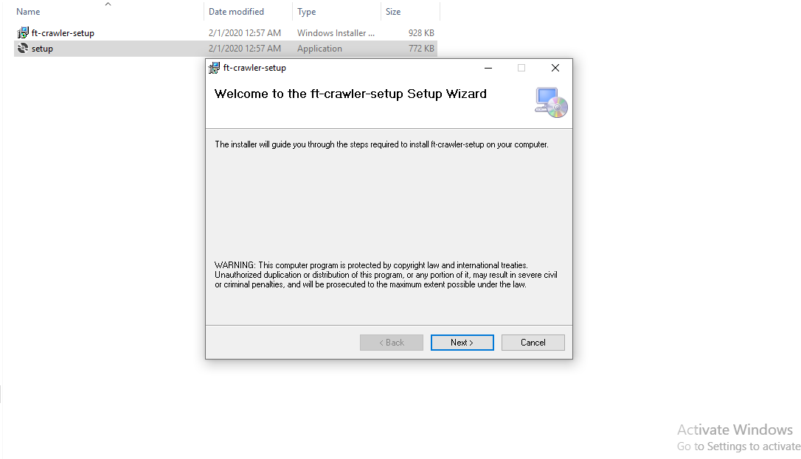
2. Save the Destination Directory , You will need that later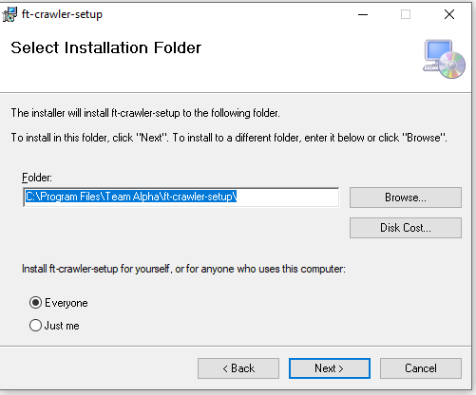
3. Complete the installation and navigate to the folder where setup is installed.

**Configuration :**

1. Open ft-crawler.exe file in any text editor , Recommended text editor is Notepad++. Open this file as administrator. 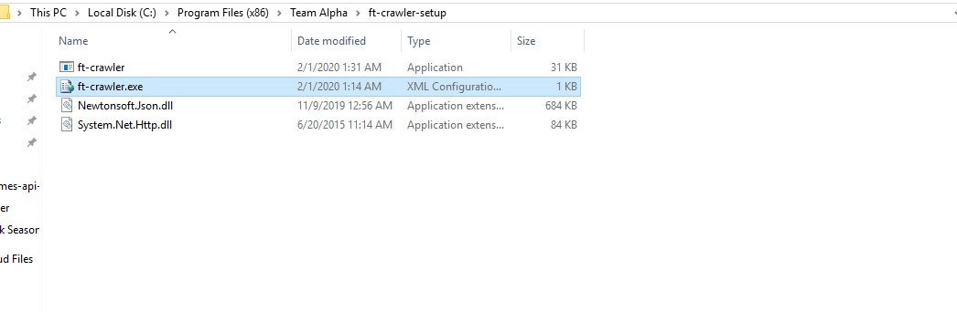
2. This file contains some configurations which you can use to alter the behavior of crawler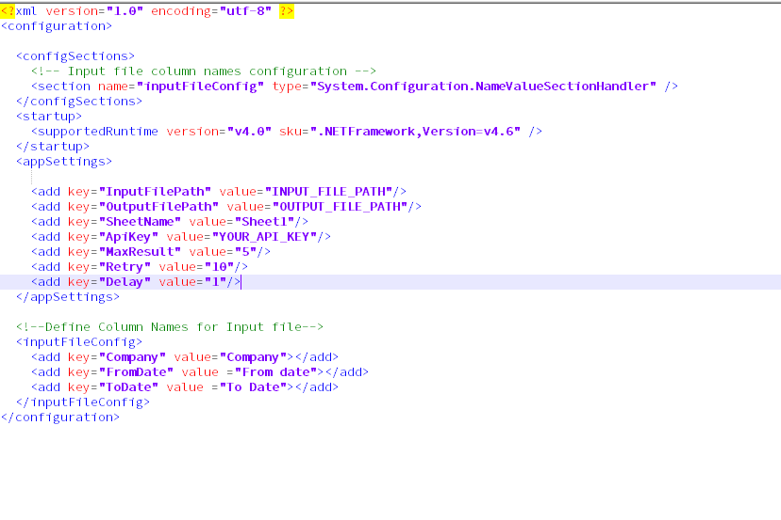
3. **appSettings:**
   * Contains the configuration about environment.
   * **InputFilePath** – Complete file path to your excel file , Supported formats are xlx or xlsx.
   * **OutputFilePath** – Complete file path to the out put file. Just give the filename with .xlsx extension. Crawler will create that file.
   * **SheetName –** Excel Sheet Name from which you want to read data .
   * **ApiKey** – your api key from FT
   * **MaxResult –** Limit crawler to save max number of news for one search
   * **Retry –** Number of Retries. In case if crawler can not find any article between the given dates, the crawler will tweak the dates – 2 days from start date and +2 days to end date. Crawler will repeat this action until the articles are found or Retry limit is reached . Default value for this is 5
   * **Delay –** Delay Time between the API Calls in seconds. Default is 1 second
4. **inputFileConfig :**  This section contains the information about the columns of input file
   * **Company :** Column name for company name
   * **FromDate:** Column name for start date
   * **ToDate:** Column name for end date
5. Save the file and Run the app. 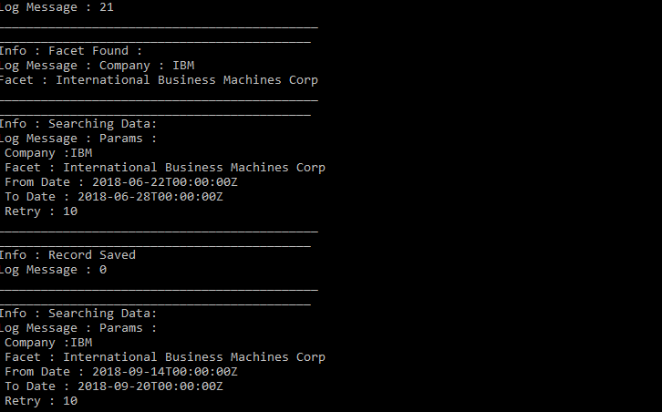

**Error Handling**

* Console will show the Error in details. In case of any issue take the screen shot of error and contact Developer.
* You may face an Error related to “OLEDB provider not found on local machine”. In this case you need to go to the following link and install 32 bit version of oledb drivers. These drivers are required to crawler to read and write excel file

<https://www.microsoft.com/en-us/download/details.aspx?id=13255>

**Note:**

* Do not open any input or output file during the crawling is running.